Text formatting template

First name Last name of Author 1¹ [Times New Roman; 12 pt, bold]
ORCID of Author 1 wwww-xxxx-yyyy-zzzz [Times New Roman; 10 pt]
First name Last name of Author 2¹ [Times New Roman; 12 pt, bold]
ORCID of Author 2 wwww-xxxx-yyyy-zzzz [Times New Roman; 10 pt]

ARTICLE TITLE [Times New Roman; 12 pt, bold, centered]
¹Author 1 affiliation [Times New Roman; 11 pt]
(example: ¹AGH University of Krakow, Faculty of Geo-Data Science, Geodesy and Environmental Engineering, Krakow, Poland)
e-mail Author 1 [Times New Roman; 11 pt]
²Author 2 affiliation [Times New Roman; 11 pt]
(example: ²The State University of Technology and Economics, Jaroslaw, Poland)
e-mail Author 2 [Times New Roman; 11 pt]

Abstract [Times New Roman; 10 pt, bold]
This is the content of the abstract (200 - 400 words). This is the content of the abstract (200 - 400 words). This is the content of the abstract (200 - 400 words). This is the content of the abstract (200 - 400 words). This is the content of the abstract (200 - 400 words). [Times New Roman; 10 pt]

Keywords: first keyword, second keyword, thirds keyword (2 - 4 keywords) [Times New Roman; 10 pt]

TYTUŁ ARTYKUŁU (in Polish) [Times New Roman; 12 pt, bold, centred]

Abstrakt (in Polish) [Times New Roman; 10 pt, bold]
To jest streszczenie po polsku. To jest streszczenie po polsku. To jest streszczenie po polsku. To jest streszczenie po polsku. To jest streszczenie po polsku. To jest streszczenie po polsku. To jest streszczenie po polsku. [Times New Roman; 10 pt]

Słowa kluczowe: pierwsze słowo kluczowe, drugie słowo kluczowe, trzecie słowo kluczowe [Times New Roman; 10 pt]

- TITLE OF THE MAIN CHAPTER (IN BLOCK CAPITAL LETTERS WITH CHAPTER NUMBERING) [Times New Roman; 12 pt, bold, fully justified]
This is the first chapter (Introduction) test. This is the first chapter (Introduction) test. This is the first chapter (Introduction) test. References should be numbered in order of appearance and indicated by a numeral or numerals in square brackets, e.g., [1] or [2,3]. [Times New Roman; 12 pt, fully justified]

  - Subsection title (lowercase letters with subsection numbering) [Times New Roman; 12 pt, bold, fully justified]
This is a test of this subsection. This is a test of this subsection. This is a test of this subsection. This is a test of this subsection. [Times New Roman; 12 pt, fully justified]

- TITLE OF THE MAIN CHAPTER (IN BLOCK CAPITAL LETTERS WITH CHAPTER NUMBERING) [Times New Roman; 12 pt, bold, fully justified]
This is the second chapter (Materials and Methods) test. This is the second chapter (Materials and Methods) test. This is the second chapter (Materials and Methods) test. [Times New Roman; 12 pt, fully justified]

This is an example of an equation: [Times New Roman; 12 pt, fully justified]
${\left(x+a\right)}^{n}=\sum_{k=0}^{n}{\left({n \atop k}\right)x^{k}a^{n-k}}$ or (1)
The text following an equation need not be a new paragraph. [Times New Roman; 12 pt, fully justified]

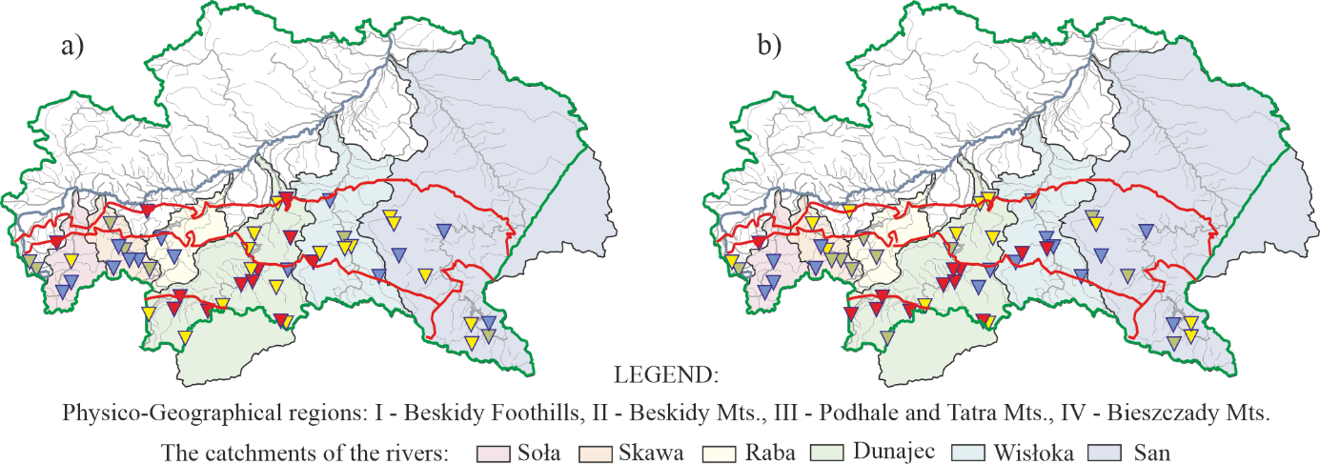
[Figures: line should be at least 0.5 pt wide, in at least 300 dpi resolution (additionally provided in a separate file, tif, jpg, png format)].

Fig. 1. This is a figure. If there are multiple panels, they should be listed as: a - description of what is contained in the first panel; b - description of what is contained in the second panel. Figures should be placed in the main text near to the place where they are cited for the first time. The maximum size of the drawing is: width 17 cm, height 19 cm. [Times New Roman; 10 pt, fully justified]
Ryc. 1. To jest rysunek. Jeśli rysunków jest wiele, powinny one być wymienione jako: a - opis tego, co jest zawarte na pierwszej rycinie; b - Opis zawartości drugiego rysunku. Ryciny powinny być umieszczone w tekście głównym w pobliżu pierwszego cytowania. Maksymalny rozmiar rysunku to: szerokość 17 cm, wysokość 19 cm. [Times New Roman; 10 pt, fully justified]

Table 1. This is a table. Tables should be placed in the main text near to the place where they are cited for the first time. Maximum table width: 17 cm. [Times New Roman; 10 pt, fully justified]
Tabela 1. To jest tabela. Tabele powinny być umieszczone w tekście głównym w pobliżu pierwszego cytowania. Maksymalna szerokość tabeli: 17 cm. [Times New Roman; 10 pt, fully justified]

Title 1 | Title 2 | Title 3 | Title 4 | Title 5
Entry 1 | Data | Data | Data | Data
Entry 2 | Data | Data | Data | Data
Entry 3* | Data | Data | Data | Data
*Tables may have a footer [text in table: Times New Roman; 10 pt, centered]

FUNDING [Times New Roman; 12 pt, bold]
If you want to provide the source of financing, please provide: “This research was funded by NAME OF FUNDER, grant number XXX” or “The research was funded by XXX”. [Times New Roman; 12 pt, fully justified]

ACKNOWLEDGMENTS [Times New Roman; 12 pt, bold]
In this section, you can acknowledge any support given which is not covered by the author contribution or funding sections. This may include administrative and technical support. [Times New Roman; 12 pt, fully justified]

REFERENCES [Times New Roman; 12 pt, bold]

Citations and references in the Supplementary Materials are permitted provided that they also appear in the reference list here. Refer simply to the reference number, for example, [1] is for a journal paper, [2] is for a book, [3] is chapter in an edited book, [4] is unpublished work, [5] is for a conference proceedings, [6] is for a thesis, [7] is for article from internet:
[A minimum of 10 literature items in the list is required, Times New Roman; 10 pt, fully justified]
- Author 1, A.B.; Author 2, C.D. Title of the article. Abbreviated Journal Name Year, Volume, page range.
- Author 1, A.; Author 2, B. Book Title, 3rd ed.; Publisher: Publisher Location, Country, 2008; pp. 154–196.
- Author 1, A.; Author 2, B. Title of the chapter. In Book Title, 2nd ed.; Editor 1, A., Editor 2, B., Eds.; Publisher: Publisher Location, Country, 2007; Volume 3, pp. 154–196.
- Author 1, A.B.; Author 2, C. Title of unpublished work. Abbreviated Journal Name year, phrase indicating stage of publication (submitted; accepted; in press).
- Author 1, A.B.; Author 2, C.D.; Author 3, E.F. Title of Presentation. In Proceedings of the Name of the Conference, Location of Conference, Country, Date of Conference (Day Month Year).
- Author 1, A.B. Title of Thesis. Level of Thesis, Degree-Granting University, Location of University, Date of Completion.
- Title of Site. Available online: URL (accessed on Day Month Year).

